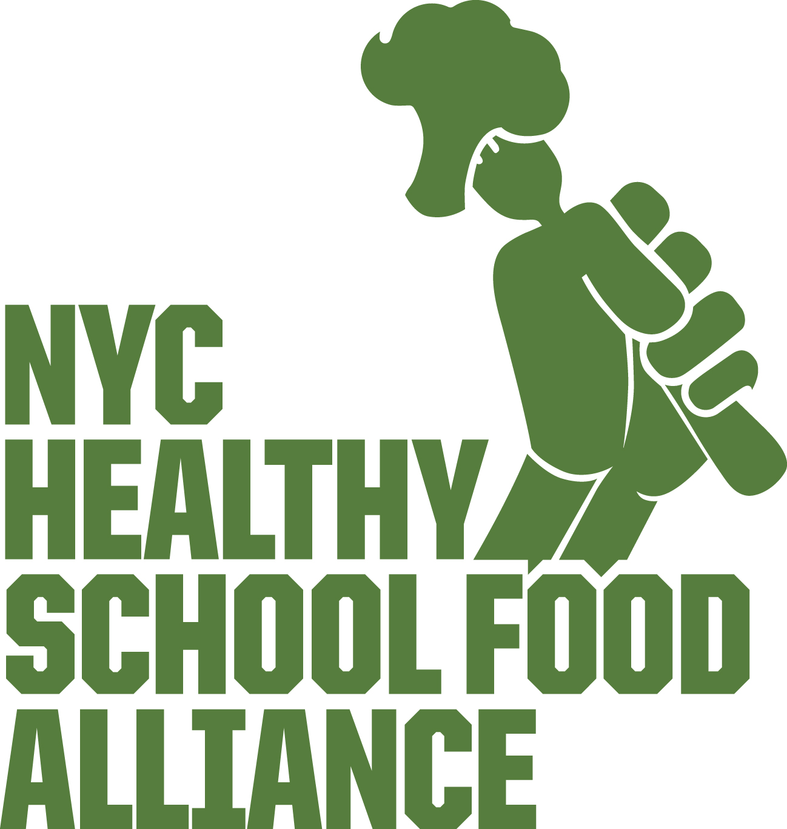

Gardens and Garden Education for All Children.

BUDGET REQUEST: Allocate funding for a 5-year plan to build gardens and hire garden staff to support edible gardens in all elementary schools.

WHY?

Summary of Garden Benefits: Children grow more than food when they plant gardens. They live healthier, they thrive academically, and expand socio-emotionally as well.

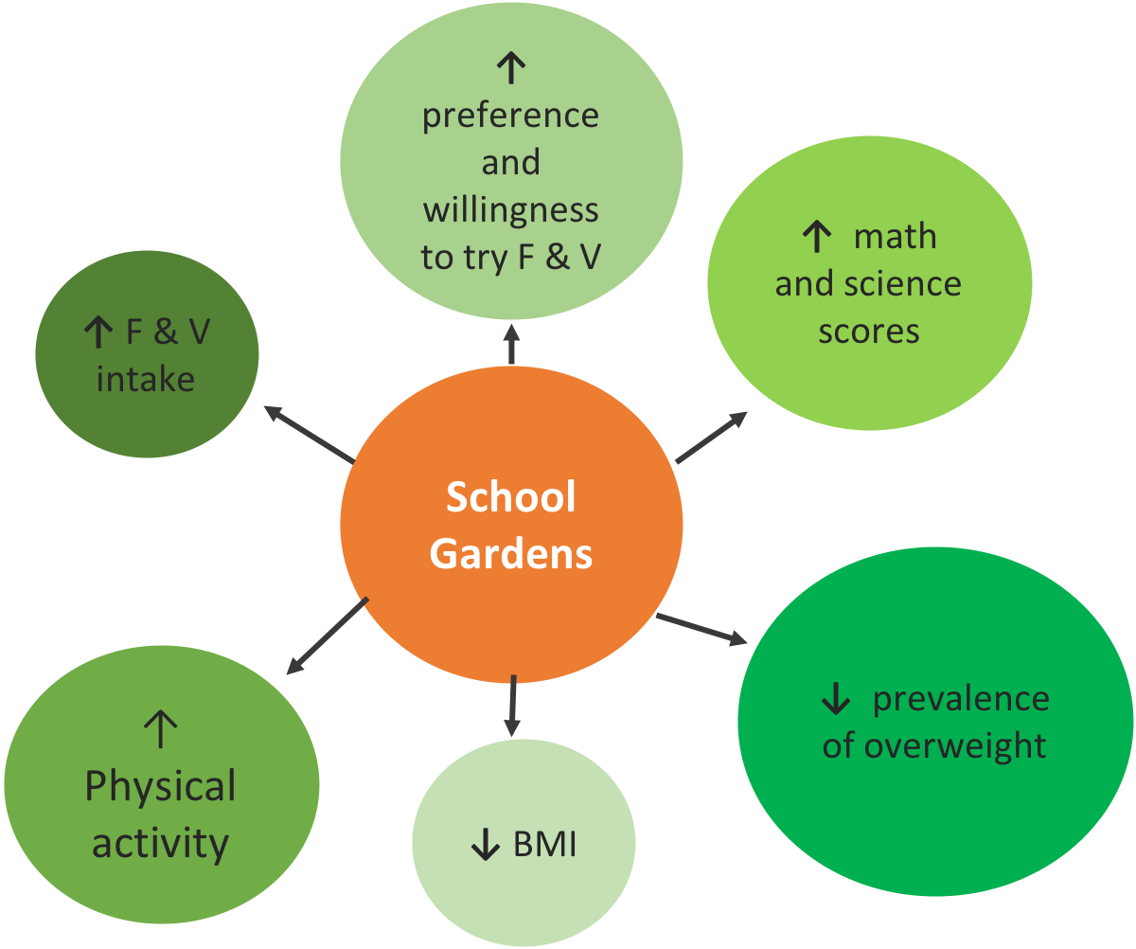

- Children Who Grow their Food are Healthier: According to the FoodCorps evaluation, children in schools that provide frequent hands-on experiences in the school garden have 3 times more fruit and vegetables during school lunch (40). According to another study at Cornell this effect carries over to increased availability of fruit and vegetables at home as well (41). A garden-based nutrition education program had an even bigger effect on an increase in fruit and vegetable consumption than a nutrition education curriculum without an accompanying garden program (42).

- Gardens Improve Academic Achievement: A study across 12 school garden programs showed improved math and science scores (43).

- Gardens Help Children Become More Physically Activity: Access to school gardens and implementation of school garden programs contribute to an increase in daily physical activity levels among children (44).

