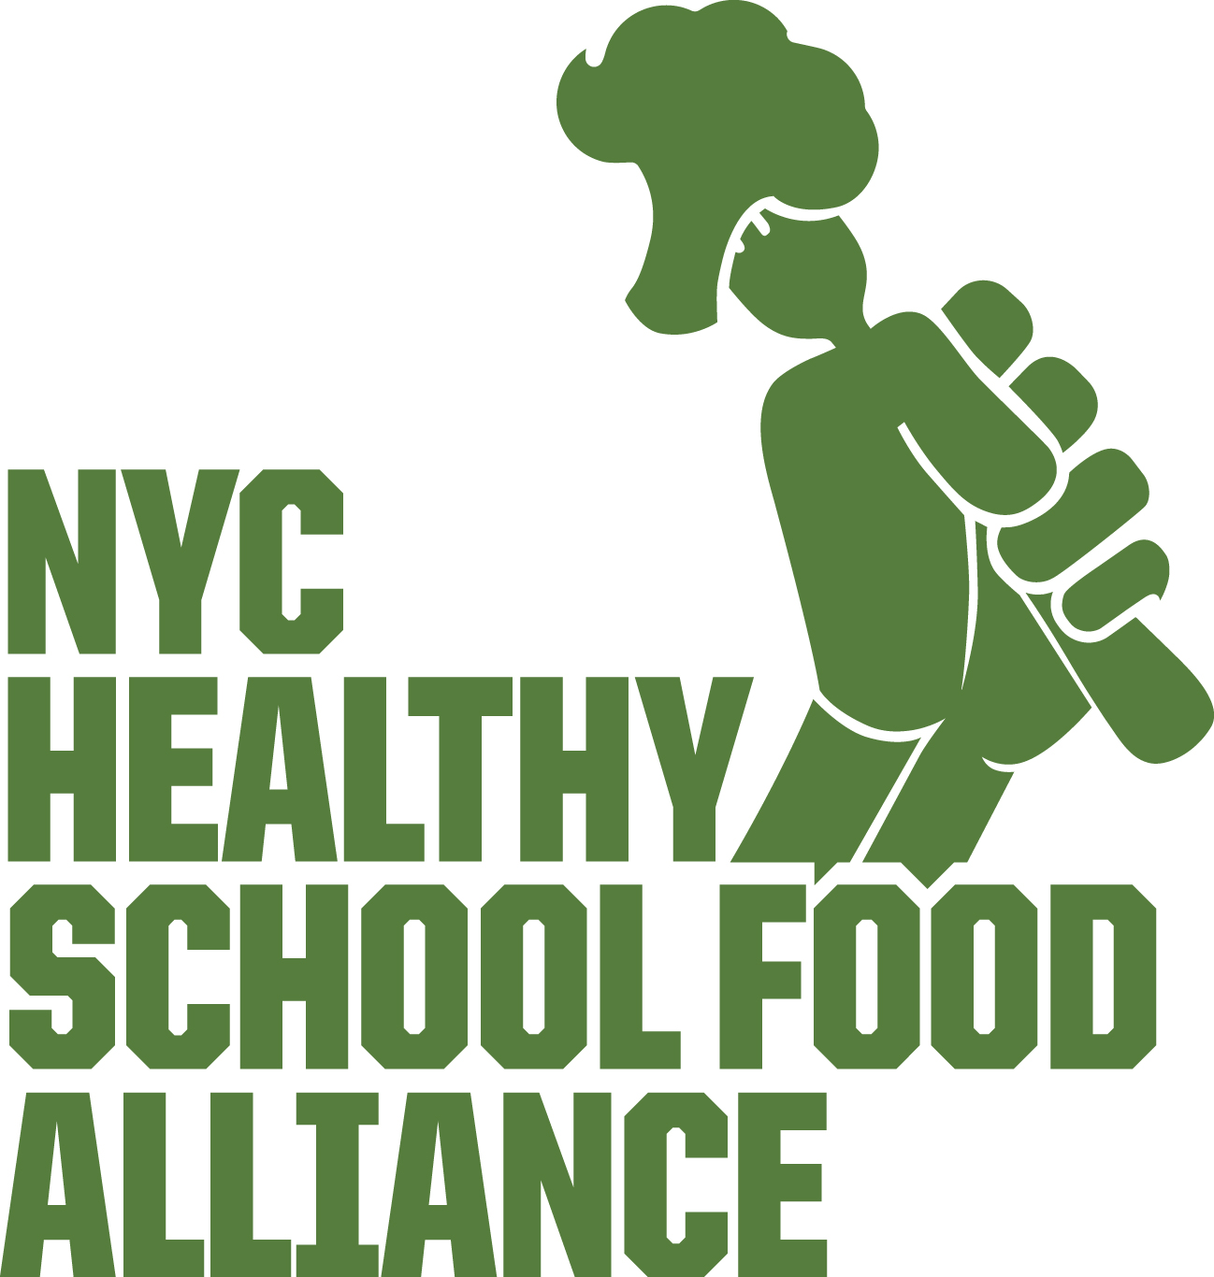

WATER JETS: A Simple Solution to Combating Childhood Obesity

BUDGET REQUEST: $2.28 million to close the gap on funding for Water Jets to ensure every public school has one.
WHY?
- Water Leads to Lower BMI: Studies have shown that access to fresh drinking water is critical: it can lead to improved weight status, reduced dental issues, and improved cognition among children and adolescents.

- Water fountains in public schools are notoriously clogged, warm, uninviting, or out of service. In 2010, the New York City Department of Health received federal grant money from the CDC to begin installing water jets — electrically cooled, large, clear jugs with a push lever for fast dispensing. But, as of 2016, only 55 percent of schools had them.

- Water Jets Fight Obesity: Water jets have been shown to be an important tool in fighting obesity. According to a study published in JAMA Pediatrics that was conducted in New York City’s public elementary and middle schools, installing water jets in cafeterias was associated with a small but significant average weight loss among students. “Water jets could be an important part of the toolkit for obesity reduction techniques at the school setting,” the study’s authors concluded.

- Better than Chocolate Milk! Rather than funding water jets, DOE continues to purchase chocolate milk. We ask that the City Council change this by adding more fresh water to the lunchroom and close the gap on water jets.

COST: 800 schools need water jets
Double bowl dispenser $850.00 = $680,000
Hydration Carts: $2000 each = $1.6 million
Total: $2.28 million

