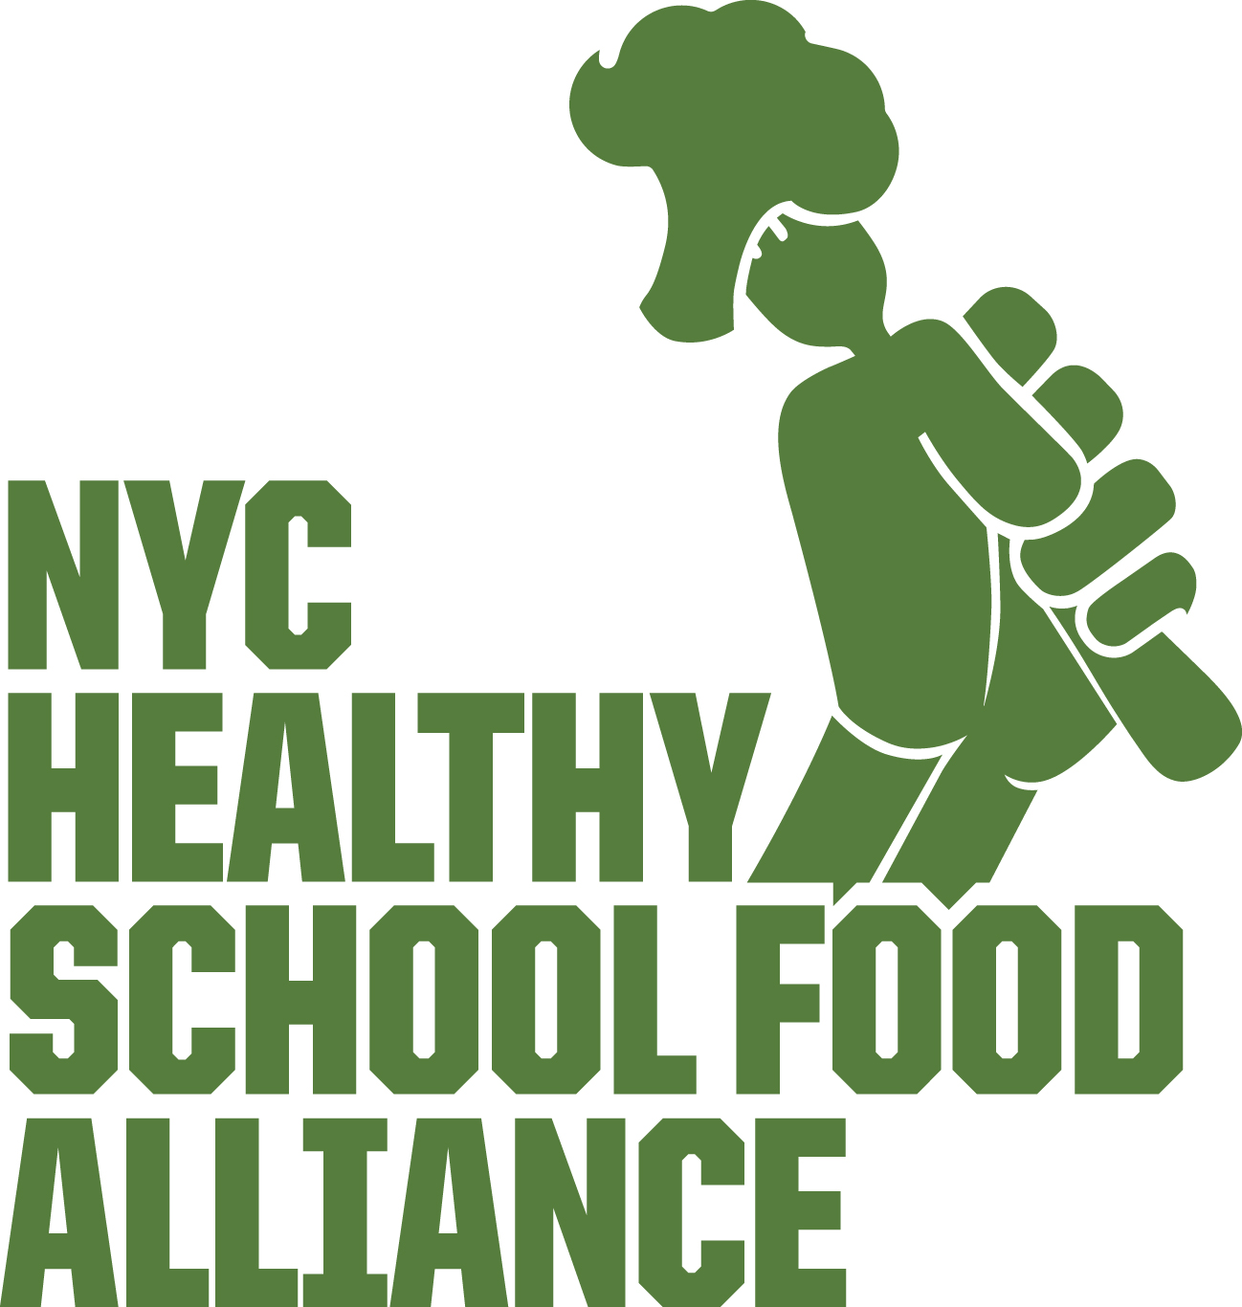

Food & Nutrition Education for All Children.
LEGISLATIVE REQUST: Require the DOE to deliver nutrition education as part of its elementary, middle and high school curriculum on an annual basis.

BUDGET REQUEST: Continue to fund ($250K) the Food-Ed Hub at the Tisch Food Center, dedicated to developing policy to bringing food education to all public school children.

WHY?

- Food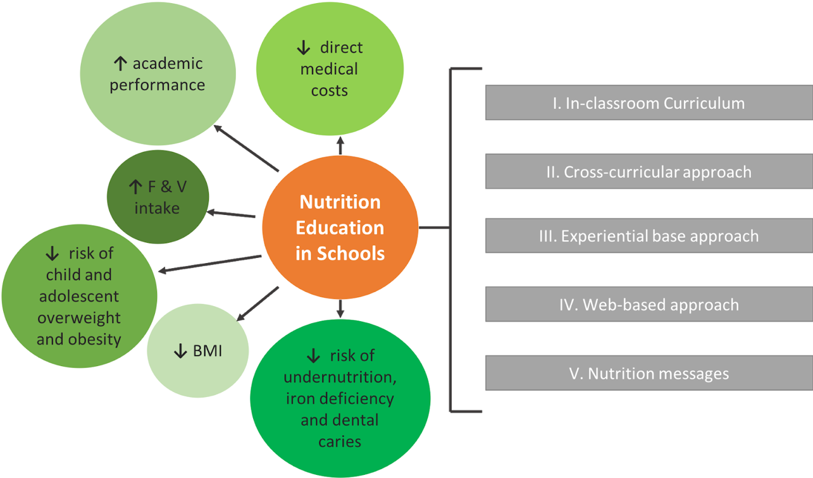 Education Means Better Health and Academic Outcomes According to a National Wellness Policy Study, well-implemented nutrition education can help children obtain healthy weights and BMIs, increase fruit and vegetable consumption, develop positive attitudes towards those foods, and improve academic performance (23). Yet research published by the Tisch Food Center shows that nearly half the city’s schools lack access to external food and nutrition education programs (25).

- Food Education = Lower Medical Costs and Longer Life Expectancy: Nutrition education programs are cost-effective, saving $900 - $12,000 for each additional life-year resulting from obesity prevention and were predicted to save $8 million in direct medical costs associated with obesity when implemented at elementary school (35).

